Yahoo Data Not Reliable

Both screenshots taken 6/13/2020. Yahoo data is garbage: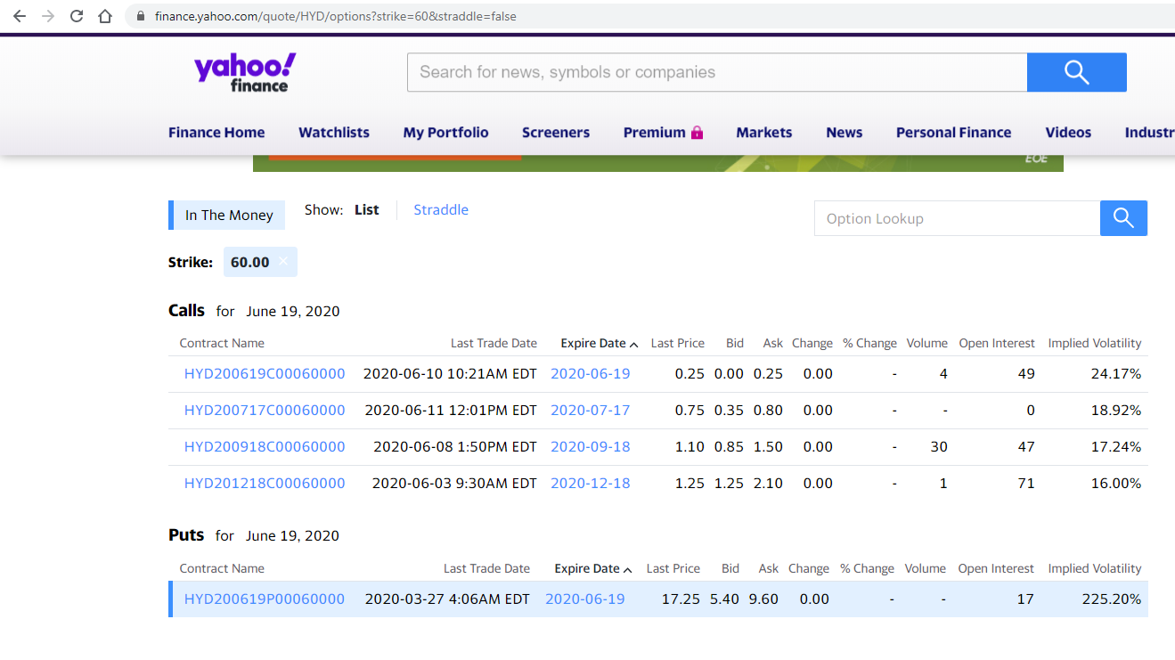Puts are missing and the 6/19 60P quote is wrong ^

